**ORU_Lab_TheraDoc Requirements**

**Version 1.3**

**Prepared By: Art Schwartz & Lois Whitley**

**Date: 7/30/2019**

Document Control 3

Resources 3

Project Distribution List 3

Document Version Control 3

1. Introduction 4

1.1 Purpose 4

1.2 Project Scope 4

1.3 Terminology Standards 4

1.3.1 Acronyms 4

1.3.2 Glossary 4

1.4 Document References 4

*2.* Diagram 5

3. Requirements 6

3.1 Functional Requirements 6

3.2 Non-Functional Requirements 8

3.3 Messaging Protocols 8

3.3.1 Inbound to the BayCare Cloverleaf 9

3.3.2 Outbound to the Vendor 9

3.3.3 Inbound From BayCare Cerner 9

4. HL7 Messaging 9

4.1 Messaging Format 9

4.1.1 Segments 9

4.1*.*2 Messaging Event Types 10

4.1*.*3 Cloverleaf Configuration Files 10

4.1.4 Cloverleaf Site Location 10

4.2 Data Transformation Requirements 10

4.3 Sample Message 14

5. Testing 15

5.1. Unit Testing Scenarios 15

5.2 Integrated Testing Scenarios 15

5.3 Testing Approvals 15

5.4 Piloting 16

5.5 Approvals 16

6. Deployment / Implementation Model 16

6.1 Alerts 16

Appendix A: Risks and Concerns 17

Appendix B: Issues List 17

# **Document Control**

## Resources

|  |  |  |
| --- | --- | --- |
| **Name** | **Role** | **Email** |
| Art Schwartz | IS Integration Analyst | [Art.schwartz@baycare.org](mailto:Art.schwartz@baycare.org) |
|  |  |  |
|  |  |  |

## Project Distribution List

## Document Version Control

|  |  |  |  |
| --- | --- | --- | --- |
| **Version** | **Date** | **Modifier** | **Description** |
| V1.0 | 11/14/2016 | Lois Whitley | Originally Created |
| V1.1 | 1/3/17 | Art Schwartz | Updated Messaging Protocols |
| V1.2 | 3/22/18 | Tiffany Bohall | Updated Functional Requirements filter |
| V1.3 | 07/30/19 | Yitzhak Magoon & Tiffany Bohall | Updated document for Cerner Model implementation |
|  |  |  |  |

# 1. Introduction

## 1.1 Purpose

The purpose of this document is to outline the Results (ORU) interface requirements for the TheraDoc application from Cerner PathNet.

## 1.2 Project Scope

Integration for the TheraDoc application includes an ADT interface from Soarian, ADT interface from Cerner for Heights, Weights and Allergies, Orders from the Cerner PharmNet (Pharmacy) system, and results from Cerner PathNet (Lab) and GE Centricity IDX (RIS). The There is a Cerner SurgiNet CCL component that passes surgical procedure information to TheraDoc, but this is a flat file and does not pass through Cloverleaf.

## 1.3 Terminology Standards

### 1.3.1 Acronyms

**ADT** – Admission, Discharge and Transfer message

**CCL** – Cerner Command Language; used to query the database and put the information in a user-friendly format

**ORU** – Observation Result/Unsolicited; this is a raw feed form Cerner PathNet or GE Centricity IDX (Radiology) – the same feed goes into Cloverleaf that comes out and goes to TheraDoc

**RDE** – Pharmacy Encoded Order Message

**RIS** – Radiology Information System

### 1.3.2 Glossary

**TheraDoc** – clinical surveillance application name

**Premier, Inc.** – vendor name

## 1.4 Document References

TDoc_Spec_Ch_05_Lab_Micro

# *2.* Diagram

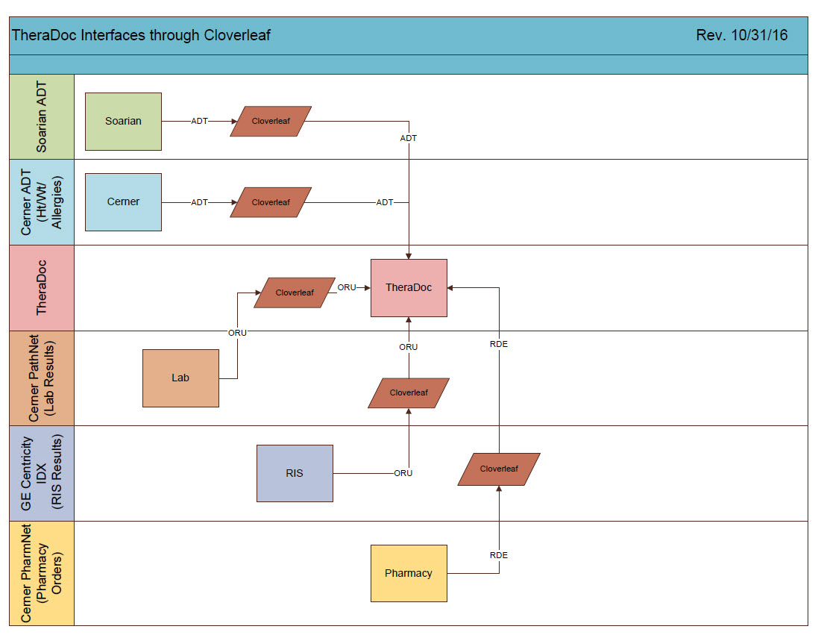

# 3. Requirements

## 3.1 Functional Requirements

Provide detail for the below functional requirements. The message transformation requirements for the components defined in this specification should be specified in section 4.2 of this document.

|  |  |  |
| --- | --- | --- |
| **Cloverleaf** |  |  |
| **Number** | **Requirement Name** | **Requirement Description** |
| FR.2019.7.29.1 | tpsCernerCommonCode  (on inbound tab of source connection) | Setting default calue of MSH.5.1 to PV1.3.7    Over ride MSH.5 if PV1.18 =JHOUTREACH, hard code SJH to MSH.5.  If PV1.18 =WOOUTREACH, hard code WHH to MSH.5 and PV1.18 =MPOUTREACH, hard code MPH to MSH.5.    Remove patient email from PID.11    Iterate through PID.11 looking for Home address and populate just these values outbound in PID.11    Blank our PID.19 is SSN=999999999    Replace & character with the word ‘and’ in OBR.13, OBR.27.7 and OBR.31.2. |
| FR.2018.3.22 | tpsAdvHL7Filter  (on inbound tab of source connection) | Suppressing zzzFormbuilder in OBR.4  Suppressing MDC in PV1.39  Suppressing DCP, GENERIC and CODE in OBR.4.1  Suppressing AP Lab results where OBR.25 (result status) is INERROR or X. |
| FR.2019.7.29.2 | tpsAdvHL7Filter  (on each route outbound) | Suppress message if OBX.3.0 = S  Suppress message if OBR.4.0 =L11895  If MSH.4 =*** (facility acronym), continue |
| FR.2019.7.29.3 | tpsCernerLabResultsModifier | Null PID.5.7    Null various PV1.19 visit number fields:  PV1.19.2  PV1.19.3  PV1.19.4.1  PV1.19.4.2  PV1.19.4.3  PV1.19.5  PV1.19.6.1  PV1.19.6.2  PV1.19.6.3    Swap various ORC.2 and ORC.3 fields:  ORC.2.1 and ORC.3.1  ORC.2.2 and ORC.3.2  ORC.2.3 and ORC.3.3  ORC.2.4 and ORC.3.4    Swap various OBR.2 and OBR.3 fields:  OBR.2.1 and OBR.3.1  OBR.2.2 and OBR.3.2  OBR.2.3 and OBR.3.3  OBR.2.4 and OBR.3.4    If OBX.3.3 =LOINC, swap OBX.3.4 with OBR.3.1 and swap OBX.3.5 with OBX.3.2.  Else, swap OBX.3.4 and OBX.3.1, OBX.3.5 and OBX.3.2 and OBX.3.6 and OBX.3.3. |

|  |  |  |
| --- | --- | --- |
| **Cerner** |  |  |
| **Number** | **Requirement Name** | **Requirement Description** |
| FR.2018.01.1 | **ESO Interface Trigger:**  Observation Reporting/ORU Discrete Gen Lab/CE Server GLB/GRP (CQM Class: CE) | This trigger causes the BayCare Laboratory results to be processed outbound when entered in Pathnet as long as the result items are not aliased with DONOTSEND for contributor source INVISION on code set 72.  - The following segments are set to be sent outbound by this trigger:   * HL7 MSH * HL7 PID * HL7 PV1   HL7 OBR/OBX/NTE |
| FR.2018.01.2 | Global Script:  - route_out | route_out (global script): Logic to route BayCare Laboratory results to the ORU_LAB_RESULTS_OUT comserver. Logic is based on:   * Message Type = ORU, cqm_type in “AP”, “MICRO”, or “GRP” * End logic for all ORU messages outbound is sent to these comservers:   - ORU_LAB_RESULTS_OUT |
| FR.2019.07.29.2 | New scripts:  fsi_common (generic)  oru_lab_out (mod object)  fsi_add_pcpe (generic) | oru _lab_out, Mod Object script, for BayCare Laboratory  results outbound:   * Calls the fsi_common generic script to load all subroutines * Adds the correct ordering provider to OBR.16, the correct order name/description to OBR.4, and the correct order alias to OBR.3 for AP results. * Replace any primary care physician (PCP) with the PCP at the encounter level in the PD1 segment. * Deletes any DONOTSEND* result items and renumbers the OBX segments accordingly. *Note: This is a known Cerner issue where LOINC coding overrides the DONOTSEND functionality. Custom Coding was needed to fix the issue.   Filters all ORU messages if there is no OBX segment after the OBX segments are stripped as described above. |

## 3.2 Non-Functional Requirements

Provide concise detail for the below non-functional requirements. The below requirements must be evaluated for every project.

|  |  |  |
| --- | --- | --- |
| **Cloverleaf** |  |  |
| **Number** | **Requirement Name** | **Requirement Description** |
| NFR.20XX.1.0 | Click here to enter text. | Click here to enter text. |

## 3.3 Messaging Protocols

Below are listed the details for the messaging protocols that will be leveraged for this integration. Please see the reference document located on the Integration SharePoint server: <insert link to document here>

### 3.3.1 Inbound to the BayCare Cloverleaf

### 3.3.2 Outbound to the Vendor

TCP/IP

### 3.3.3 Inbound From BayCare Cerner

TCP/IP

# 4. HL7 Messaging

## 4.1 Messaging Format

### 4.1.1 Segments

The segments utilized for this interface are:

MSH

PID

PV1

ORC

OBR

OBX

*Message Construction Notes:*

*[Square Brackets] – Optional*

*{Curly Brackets} – Repeatable*

*MSH – Message Header*

*PID – Patient ID segment*

*PV1 – Patient Visit segment*

*ORC – Common Order segment*

*OBR – Observation Request segment*

*OBX – Observation/Result segment*

*[{ – Start of optional, repeatable group*

*}] – End of optional, repeatable group*

### 4.1*.*2 Messaging Event Types

Below are the messages types necessary for this integration and supported by TheraDoc and Soarian.

|  |  |
| --- | --- |
| **Event Type** | **Description** |
| R01 | Unsolicited transmission of an observation message |
| R03 | Display-oriented results, query/unsolicited update for backward compatibility only |

### 4.1*.*3 Cloverleaf Configuration Files

Click here to enter text.

### 4.1.4 Cloverleaf Site Location

theradoc_25

## 

## 4.2 Data Transformation Requirements

Results from Lab is a raw feed to TheraDoc there is no translate or transformation of data.

| **Field Description** | **HL7 Field Loc.** | **Required Y/N** | **Data Type** | **Length** | **Notes** |
| --- | --- | --- | --- | --- | --- |
| Message Header | MSH |  |  |  | Pathcopy MSH |
| Sending Application | MSH.3 |  |  |  | CERNER |
| Sending Facility | MSH.4 |  |  |  |  |
| Receiving Application | MSH.5 |  |  |  | BAYCARE |
| Date/Time of Message | MSH.7 |  |  |  |  |
| Message Type | MSH.9 |  |  |  | i.e ORU^R03 |
| Message Control ID | MSH.10 |  |  |  |  |
| Patient Identification | PID |  |  |  | Primary means of identifying patients in TheraDoc |
| Set ID | PID.1 |  |  |  |  |
| Patient ID (External ID) | PID.2 |  |  |  | Person Identifier in TheraDoc |
| Patient ID (Internal ID) | PID.3 |  |  |  | MRN; matches value against TheraDoc patient table |
| Alternate Patient ID | PID.4 |  |  |  |  |
| Patient Name | PID.5 |  |  |  | FamilyName^GivenName |
| Date/Time of Birth | PID.7 |  |  |  | YYYYMMDD; calculates current age of patient |
| Sex | PID.8 |  |  |  | M=Male  F=Female  U=Unknown |
| Patient Address | PID.11 |  |  |  |  |
| Phone Number | PID.13 |  |  |  |  |
| Marital Status | PID.16 |  |  |  |  |
| Patient Account Number | PID.18 |  |  |  | Primary identifier for encounters; matches against TheraDoc encounter table |
| Social Security Number | PID.19 |  |  |  |  |
| Birth Order | PID.25 |  |  |  |  |
| Patient Visit | PV1 |  |  |  |  |
| Set ID | PV1.1 |  |  |  |  |
| Patient Class | PV1.2 |  |  |  | I=Inpatient  O=Outpatient  E=Emergency  P=Pre-Admit |
| Assigned Patient Location | PV1.3 |  |  |  | Used for reporting and patient’s location at time of specimen collection for Lab  (NS^Room^Bed^Facility) |
| Admission Type | PV1.4 |  |  |  |  |
| Attending Doctor | PV1.7 |  |  |  | ProvNum^FamilyName^GivenName^ |
| Hospital Service | PV1.10 |  |  |  | Displays as sent |
| Admit Source | PV1.14 |  |  |  |  |
| VIP Indicator | PV1.16 |  |  |  |  |
| Admitting Doctor | PV1.17 |  |  |  |  |
| Patient Type | PV1.18 |  |  |  |  |
| Discharge Disposition | PV1.36 |  |  |  |  |
| Service facility | PV1.39 |  |  |  |  |
| Account Status | PV1.41 |  |  |  |  |
| Admit Date/Time | PV1.44 |  |  |  | YYYYMMDDHHMM |
| Discharge Date/Time | PV1.45 |  |  |  | YYYYMMDDHHMM |
| Common Order | ORC |  |  |  |  |
| Order Control | ORC.1 |  |  |  |  |
| Observation Request | OBR |  |  |  |  |
| Set ID | OBR.1 |  |  |  |  |
| Filler Order Number | OBR.3 |  |  |  | Unique number to identify order |
| Universal Service Identifier | OBR.4 |  |  |  | Identifies the order/test being performed; Used for vocabulary mapping and message categorization; not displayed in TheraDoc |
| Observation Date/Time | OBR.7 |  |  |  | Specimen collection date/time |
| Specimen Source | OBR.15 |  |  |  | Required for micro results |
| Ordering Provider | OBR.16 |  |  |  |  |
| Filler Field 1 | OBR.20 |  |  |  |  |
| Results Report/Status Change Date/Time | OBR.22 |  |  |  |  |
| Diagnostic Service Section ID | OBR.24 |  |  |  |  |
| Result Status | OBR.25 |  |  |  | P=Preliminary  F=Final  C=Corrected  I=In Lab  A=Amended Report  R=Results Entered  X=No Results / Cancelled  O= Order Received  U=Final |
| Parent Result | OBR.26 |  |  |  | Required in susceptibility testing to link results to an organism |
| Quantity/Timing | OBR.27 |  |  |  |  |
| Principal Result Interpreter | OBR.32 |  |  |  |  |
| Observation Result | OBX |  |  |  |  |
| Set ID | OBX.1 |  |  |  |  |
| Value Type | OBX.2 |  |  |  |  |
| Observation Identifier | OBX.3 |  |  |  | Identifier^Text^^Alternate Identifier^Alternate Text  Provides identifier for observation for general lab; Identifies antibiotic tested in susceptibility testing |
| Observation Value | OBX.5 |  |  |  | Typically numeric value for general lab; organism code in micro; provides measured value of susceptibility test |
| Units | OBX.6 |  |  |  | Unit of measure of value provided in OBX.5 |
| Reference Range | OBX.7 |  |  |  | Uses these formats:   * a-b * >a * <a |
| Abnormal Flags | OBX.8 |  |  |  | 1) General Lab: Empty or N = normal result; any other value or (A) is abnormal  Abnormal result triggers”  LL = Critically Low  HH = Critically High  AA = Critically Abnormal  2)Provides interpretation for susceptibility testing:  S=Susceptible  I=Intermediate  R=Resistant |
| Observation Result Status | OBX.11 |  |  |  |  |
| Date/Time of Observation | OBX.14 |  |  |  |  |

## 4.3 Sample Message

**From Cerner to TheraDoc:**

MSH|^~\&|HNAM|CERNER|MPH|BAYCARE|20190717104705||ORU^R01|Q4432199801T5825926159||2.3||||||8859/1

PID|1|2006002817^^^BayCare MRN^MRN|2006002817^^^BayCare MRN^MRN||AKITESTING3^TEST^^^^^||19500301|F||||||||||1006009618^^^BayCare FIN^FIN NBR|||||||0

PV1|1|I|A4PP^^^MPH^^Nurse Unit(s)^MPH||||MS052182^TESTER^TESTER^^^^^^BayCare Dr Number^Personnel^^^ORGANIZATION DOCTOR^CACTUS|||||||||||I|^^^&&^^&&||||||||||||||||||||MPH||Active|||20190619095400

OBR|1|^^^|15230466561^HNAM_ORDERID^^|4900233^CREAT|||20190717104400|||||||20190717104400|Blood&Blood^^^^^Venous Draw|MS052182^TESTER^TESTER^^^^^^BayCare Dr Number^Personnel^^^ORGANIZATION DOCTOR^CACTUS||||000002019198000042^HNA_ACCN~74112840^HNA_ACCNID||20190717104521||Lab|P||1^^^20190717104400^^ROUTINE~^^^^^TODAY|||||||||20190717104400

OBX|1|NM|L670671^Creatinine^BCLAB^2160-0^CREATININE:MCNC:PT:SER/PLAS:QN:^LOINC||3.000|mg/dL^mg/dL|0.300-1.300^0.300^1.300|H|||C|||20190717104702||^Lcllsd^Nfuhq^G^^^^^^Personnel|^^^CD:719302443

OBX|2|ST|CD:3244548805^AKI Risk^^CD:3244548805^AKI Risk^BCLAB||N/A||||||F|||20190717104523||^SYSTEM^Donotchange^^^^^^^Personnel|^^^CD:719302443

NTE|1|RESCOM|Unable to calculate AKI Risk

# 

# **5. Testing**

## 5.1. Unit Testing Scenarios

|  |  |
| --- | --- |
| **Scenario** | **Expected Result** |
|  |  |
|  |  |
|  |  |
|  |  |
|  |  |

## 5.2 Integrated Testing Scenarios

|  |  |
| --- | --- |
| **Scenario** | **Expected Result** |
|  |  |
|  |  |
|  |  |
|  |  |
|  |  |
|  |  |

## 5.3 Testing Approvals

|  |  |  |  |
| --- | --- | --- | --- |
| **Testing Phase** | **Date** | **Department** | **Team Member** |
| PH1.UNIT |  |  |  |
| PH1.INTEGRATED |  |  |  |

### 

## 5.4 Piloting

List the facilities and associated networks in scope for pilot testing.

## 5.5 Approvals

|  |  |  |  |
| --- | --- | --- | --- |
| **Testing Phase** | **Date** | **Department** | **Team Member** |
| PH1.0 |  |  |  |
|  |  |  |  |
|  |  |  |  |

# 6. Deployment / Implementation Model

Provide the detail as to how to deploy the solution defined in the IDBB from both the BAYCARE and vendor perspective.

## 6.1 Alerts

Are you going to need alerting on this connection?

|  |  |
| --- | --- |
| Yes |  |
| No |  |

If the answer is yes, please complete the table below:

|  |  |  |  |
| --- | --- | --- | --- |
| **Site Name** | **Hours of Support** | **Distribution Group** | **Comments** |
|  |  |  |  |
|  |  |  |  |

# Appendix A: Risks and Concerns

|  |  |  |  |  |  |  |  |  |
| --- | --- | --- | --- | --- | --- | --- | --- | --- |
| **Project Name** |  |  | | |  |  |  |  |
| **Number** | **Risk / Concern** | **Comment** | **Mitigation** | | |  |  |  |
| RC.2013.1.0 |  |  | |  | |  |  |  |

# Appendix B: Issues List

This is a dynamic list of the open issues related to the IDBB that remain to be solved, including but not limited to TBDs, pending decisions, information needed, conflict awaiting resolution, and the like.

|  |  |  |  |  |  |  |  |  |
| --- | --- | --- | --- | --- | --- | --- | --- | --- |
| **Project Name** |  |  | | |  |  |  |  |
| **Number** | **Issue** | **Comment** | **Fix** | | |  |  |  |
| I.2013.1.0 |  |  | |  | |  |  |  |

* End of document